**================创建表和约束================**

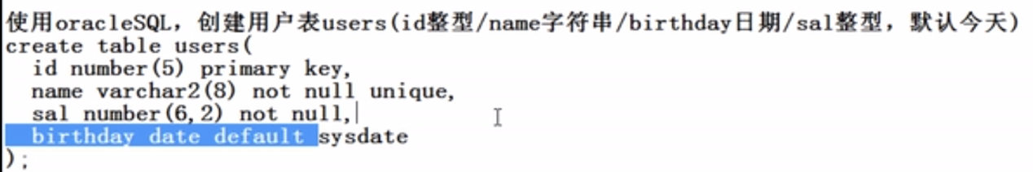

**Create table users(**

**Id number(5) primary key,**

**Name varchar2(8) not null unique,**

**Sal number(6,2) not null,**

**Birthday date default sysdate**

**);**

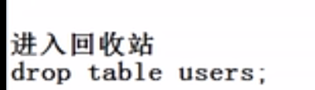

**删除表格**

**Drop table users;**

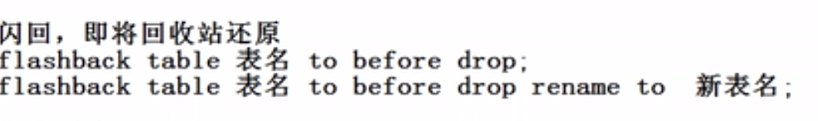

**从回收站还原表格**

**Flashback table users to before drop;**

**或**

**Flashback table users to before drop rename to 新表名**

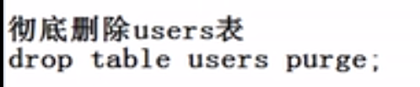

**Drop table users purge;**

**查看回收站的内容**

**show recyclebin；**

**清空回收站**

**Purge recyclebin;**

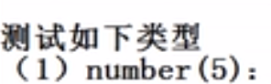

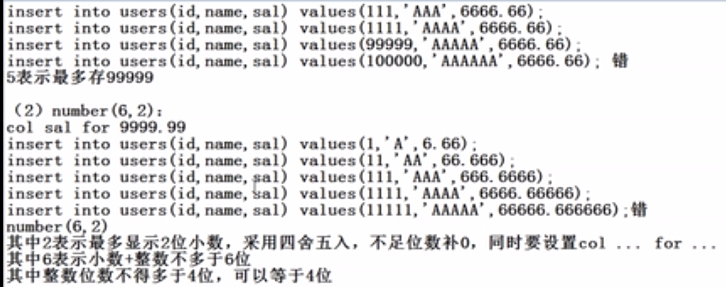

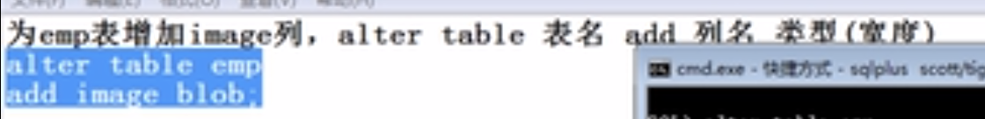

**Alter table emp add image blob;**



**Alter table emp modify ename varchar2(20);**

**删除image 列：**

**Alter table emp drop column image;**



**Alter table emp rename column ename to username;**



**rename emp to emps;**





**分两步**

1. **alter table emps drop column sal;**
2. **alter table emps add sal number(7,2) default 0;**





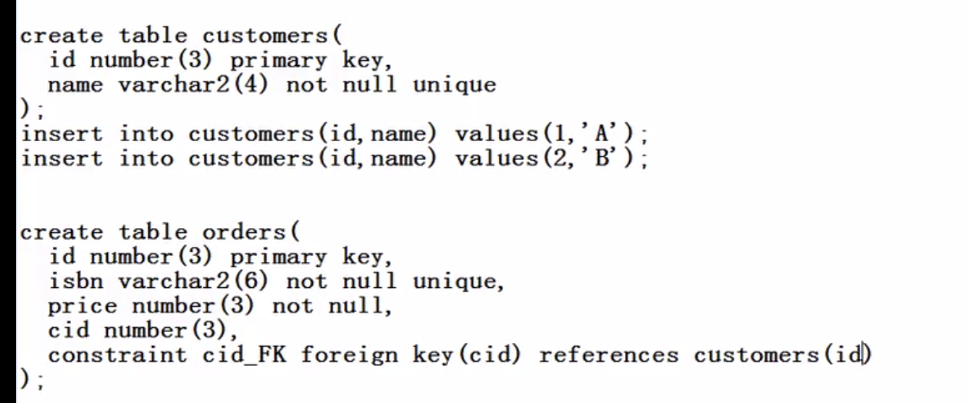

**Create table customers(**

**Id number(3) primary key ,**

**Name varchar2(20) not null unique**

**);**

**添加一点数据**

**Insert into customers(id,name) values(001,'Jack');**

**Insert into customers(id,name) values(002,'Jade');**

**Insert into customers(id,name) values(003,'Jackline');**

**Insert into customers(id,name) values(004,'Pauline');**

**Create table orders(**

**Id number(3) primary key ,**

**isbn varchar2(6) not null unique,**

**price number(3) not null,**

**cid number(3),**

**constraint cid_FK foreign key(cid) references customers(id)**

**);**

**Insert into orders(id,isbn,price,cid) values(1,'isbn10',100,1);**

**Insert into orders(id,isbn,price,cid) values(2,'isbn20',200,1);**

**Insert into orders(id,isbn,price,cid) values(3,'isbn30',10,2);**

**Insert into orders(id,isbn,price,cid) values(4,'isbn40',10,2);**



**在创建表的时候添加如下代码（红色）：**

**Create table orders(**

**Id number(3) primary key ,**

**isbn varchar2(6) not null unique,**

**price number(3) not null,**

**cid number(3),**

**constraint cid_FK foreign key(cid) references customers(id) on delete set null**

**);**

**需求2：删除客户同时删除他的所有订单**

**在创建表的时候添加如下代码（红色）：**

**Create table orders(**

**Id number(3) primary key ,**

**isbn varchar2(6) not null unique,**

**price number(3) not null,**

**cid number(3),**

**constraint cid_FK foreign key(cid) references customers(id) on delete cascade**

**);**



**create table students(**

**id number(3) primary key,**

**name varchar2(10) not null unique,**

**gender varchar2(2) not null check (gender in ('男','女') ),**

**salary number(6) not null check (salary between 6000 and 8000));**

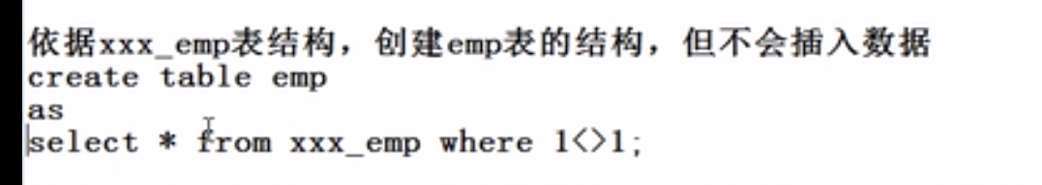

**Create table emp as select * from xxx_emp where 1<>1;**

**注意：因为1<>1为假所以没有数据**

